
SHAIKH IQBAL

Bachelor Of Business Administration
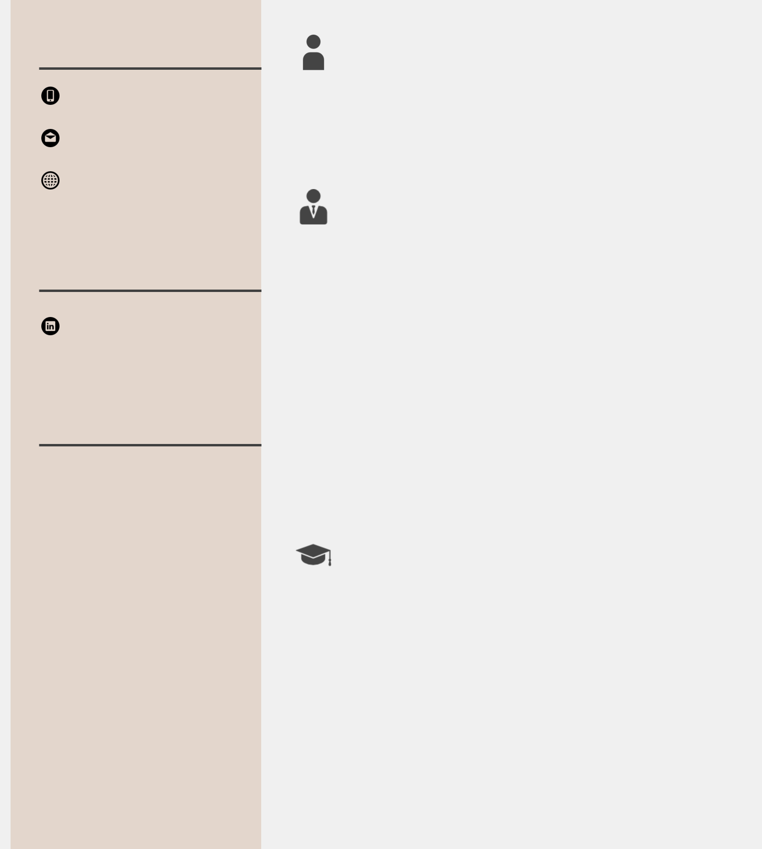

Contact Me

01797577576

iqbalmultazim95@gmail.

com

Social Profile

linkedin.com/in/shaikh-iqbal-5361b91b1

Other Info

Skills

MS Office

Financial Analysis

Strategic Thinking

Interpersonal Skill

Stock Analysis

Operation Management

Team Management

Languages

English,Bangla

 | About Me
 | who wants to work in commercial environment and
 | has a keen eye for detail and process improvement.
 | Experience
June 2022 - | BRAC Bank Limiter |Intern-SME Banking
September | Division
2022 | Division
June 2021 - | |
November
2021
 | |
 | |
Oct 2014 - Dec | Bangladesh Technical Educational Board,
2014 | Dhaka. |Pastry and Bakery Production
 | Education
2017 - 2022 | North South University |Bachelor of Business
 | Administration (BBA)
 | CGPA: 2.99
2014 - 201y | Little Jewels School |A-levels
- 2013 | Little Jewels School |O-levels

Interest  ^{Projects}

Capital Market, Trekking, | Sports, Music

|

- Appeared |

Others

EXTRA CURRICULAR

ACTIVITIES

Sub Executive Body Member

Marketing & International

BusinessClub of

North SouthUniversity

2019 - 2020, Dhaka,Bangladesh

Marketing and International

BusinessClub is one of the

functional

business clubs which is

operating under the

Department of

Marketing & International

Businessof North South

University.

Achievements/Tasks

Successfullyorganised two

inter university events

Successfully took care of

logistic operations

Successfully worked in

sponsorship team

Guided a operation team

consisting 30 members

Contact : Abir Mahmud -

abir.mahmud18@northsouth.e

du

Senior Member

The Marketing Club of North

South

University

2018 - 2019, Dhaka,Bangladesh

The Marketing Club is the

ultimate platform for the

students of

North South Universitywho

are taking Marketing as their

major or in

other businessdisciplines.
Achievements/Tasks

Successfully organised 'RFL

Presents Hashtag Marketing

V.4' which was the biggest

digital marketing competition

in Bangladesh.

Successfullyworked in the

logistic operations &

sponsorship team.

Successfullymanageda team of

10 general members.

Contact : Raihanur Rezwan -

raihanur.rezwan243@gmail.co

m

References

Rumana Huq Luva

Lecturer, Department of

Management.

North South University.

E-mail:

rumana.luva@northsouth.edu

Mahbub Farid, PMP, Adjunct

Faculty (Former Operation

Manager- JP Morgan Securities)

Department of Accounting &

Finance, North South

University.

E-mail: mfarid.ulab@gmail.com

